Model WC5WA2513U specification

The high pressure pump: model WIP5

Pump type: dual plunger reciprocal intensifier.
20:1 intensifier ratio
Max pressure: 60,000psi (400Mpa).
Continuously adjustable cutting pressure.
Max water flow rate: 0.8Gal/min (3.2L/min).
High pressure water attenuator to dampen cutting pressure fluctuations.
Reliable electronic shift
Intensifier driven by: hydraulic pump.
Hydraulic pump type: Axial piston hydraulic pump.
Hydraulic filtration in output oil path with filter cartridge clogging alarm
Hydraulic accumulator for damping the oil pressure pulsations
50HP high efficiency motor with Wye Delta soft start
Cooling method: water cooling with high efficiency plate heat exchanger. Use of electric chiller is optional with additional cost.
Water filter: 2 stage filtration included inside the pump unit.
Integrated Control panel with heavy gauge metal framework
CE certified Electronic components
All stainless fittings and tubing

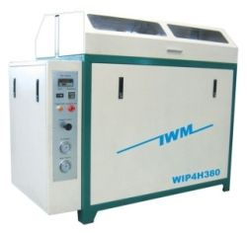

Power source: 3 phase, 220/380/415/440VAC, 50/60Hz 37kw, 50HP.
Approximate form size: 1600 x900 x1400mm, weight 1100kg.

Protective automatic shut off under the following circumstances:

- Over pressure limit.
- Over temperature limit.

CNC cutting table: model CAT2513U (4'x8')

The table consists of water tank, X-Y motion system, Z axis motion, cutting head assembly, and abrasive mini-hopper with adjustable abrasive feeding control.
Style: cantilever, water tank is made of stainless steel.
Effective cutting area: 4ft x 8 ft (1300x2500mm).
Maximum Z-axis travel: 6" (150mm).
X-Y axis motion system: ball screw, linear motion guide.
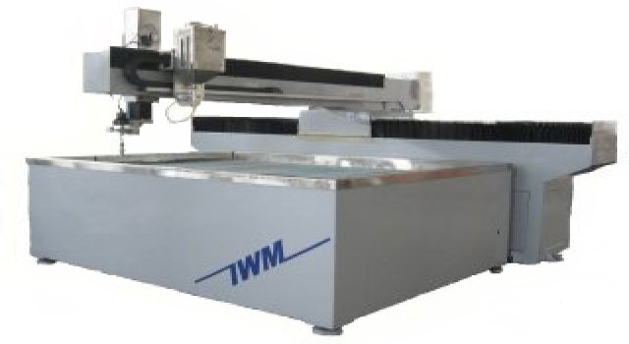

X-Y axis motion drive: AC servo motor.
Z axis motion: AC motor with speed reducer, Z axis servo is optional.
X-Y axis linear position accuracy: +/- 0.0012"(0.03mm).
X-Y axis position repeatability: +/- 0.0004"(0.01mm).
Best cutting tolerance: +/- 0.006" (0.15mm).
Maximum X-Y axis travel speed: 32ft/min (10m/min).
This machine can cut all kinds of metal, marble, granite, glass, ceramic tile, rubber, plastic, virtually any materials. This machine can cut metal up to 100mm thick.

Mini hopper for abrasive feeding:

Large size to enable long working time without floor size abrasive hopper.
Clear side view for easy monitoring.
Abrasive valve attachment for easy abrasive on/off control and abrasive flow rate adjustment.

Cutting head:

The assembly consists of pneumatically operated on/off valve and self-aligned cutting head. Maximum Abrasive flow rate: 0.5kg/min (1pound/min). Compressed air source is necessary. An air compressor is optional item from manufacturer. As an option, the cutting head can manually tilt in both x and y directions.
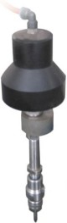

UHP tubing and plumbing kit for connection:

1/4” or 7mm OD UHP tubing from intensifier to cutting head mounted on cutting table
Stainless fittings. Rack kit to supporting installation of the tubing.

CNC controller:

CNC controller consists of advanced industrial grade computer and specialized software running on the Microsoft windows platform. The controller is capable of simultaneous X-Y axis interpolation movement. Fast accelerate or decelerate motion and high speed travel from point to point. Simulation without motion or dry run with axis motion but no jetting of water/abrasive are features included. Error stop and trace repeat are also very useful features. Out of range warning and hard stop to prevent damage capability are embedded in the system. Emergency shut off switch is provided. Optional remote control can be handy to control the motion of X-Y-Z axis when operator is away from the controller tower.

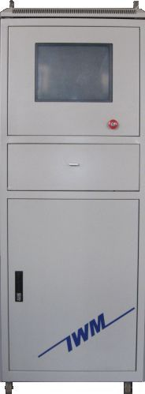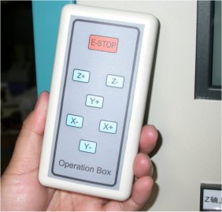

Controller Tower Remote Control

DXF file compatibility:

The controller is compatible to dxf file format. Users can save design drawing in dxf format from AutoCAD or other software and read the file into the controller. Controller will post the dxf file to G-code. The controller can also read G-code generated from other CAM software. Controller software interface is based on Microsoft Windows 98/Me/XP/VISTA.

Advanced CAD/CAM software (optional): for design drawing, automatically generating machine path, lead in/out, nesting, tool offset, and generate G code. Features are similar to AutoCAD, and with rich features of CAM.

Controller screen:

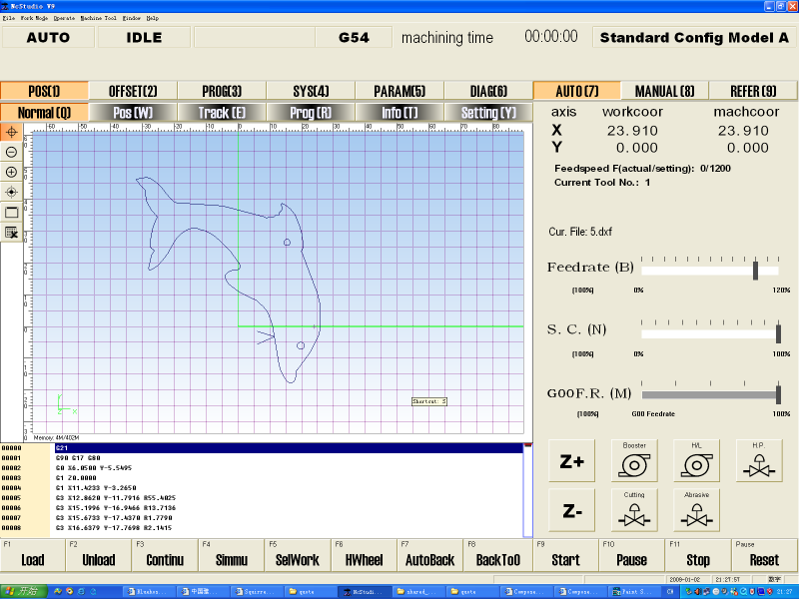

Automatic abrasive feeder (optional):

This equipment is highly recommended for larger tables.

- Requires 70psi pneumatic source
- Capacity 40 Gallon.
- Self detecting empty/full status of reservoir and start/stop feeding.
- Model number ADS-04-170.

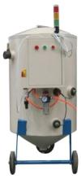

Abrasive Removal System (ARS): Optional

Instead of shoveling used abrasive from catch tank by a person, this sub-system is designed to remove used abrasive from the catch tank automatically. The system includes agitation setup to stir up the abrasive for more efficient removal of the abrasive. The used abrasive is collected in a smaller tank (not showing on photo) that can be dumped with a fork lift

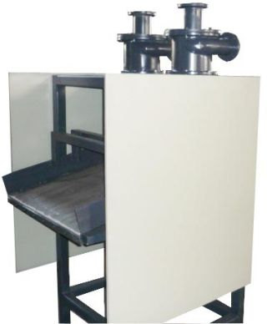

Accessories included in standard package:

High pressure tubing, Water hose, Electrical cables, 1 pcs nozzle, 2 pcs orifice, 1 tube of blue goop.
1 set of special tools for pump maintenance.

Spare parts kit (optional).

