Model WC5WA3015H specification

The high pressure pump:
Pump type: dual plunger reciprocal intensifier.
Intensifier driven by: hydraulic pump.
Max pressure: 55,000psi (380Mpa).
Max water flow rate: 0.8Gal/min (3.2L/min).
Attenuator 0.35Gal (1.4 Liters).
Cooling method: forced water. Or oil chiller as an option
Hydraulic fluid tank capacity: 42Gal (170L).
Water filter: 2 stage filtration included inside the pump unit.
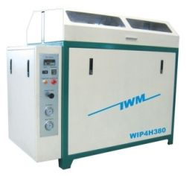

Power source: 3 phase, 220/380/415/460/VAC, 50/60Hz 37kw. Form size: 1600 x900 x1400mm, weight 1100kg.

Protective automatic shut off under the following circumstances:

- Over pressure limit.
- Over temperature limit.

CNC cutting table:

The table consists of water tank, X-Y motion system, Z axis motion, cutting head assembly, and abrasive mini-hopper with adjustable abrasive feeding control.
Style: overpass, water tank is made of stainless steel.
Effective cutting area: 5ft x 10 ft (1500x3000mm)
Maximum Z-axis travel: 6" (150mm)
X-Y axis motion system: ball screw, linear motion guide
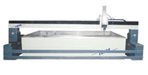

X-Y axis motion drive: AC servo motor, Z axis motion: AC motor with speed reducer.
X-Y axis position repeatability: +/- 0.0012"(0.03mm).
Maximum cutting tolerance: +/- 0.006" (0.15mm). Maximum X-Y axis travel speed: 32ft/min (10m/min).
This machine can cut all kinds of metal, marble, granite, glass, ceramic tile, rubber, plastic, virtually any materials. This machine can cut metal up to 70mm thick.

Cutting head:

The assembly consists of pneumatically operated on/off valve and self-aligned cutting head. Maximum Abrasive flow rate: 0.5kg/min (1pound/min). Compressed air source is necessary. An air compressor is optional item from manufacturer. As an option, the cutting head can manually tilt in both x and y directions.

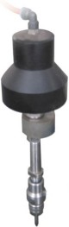

CNC controller:

CNC controller consists of advanced industrial grade computer and specialized software running on the Microsoft windows platform. The controller is capable of simultaneous X-Y axis interpolation movement. Fast accelerate or decelerate motion and high speed travel from point to point. Simulation without motion or dry run with axis motion but no jetting of water/abrasive are features included. Error stop and trace repeat are also very useful features. Out of range warning and hard stop to prevent damage capability are embedded in the system. Emergency shut off switch is provided. Remote control is provided to control the motion of X-Y-Z axis when operator is away from the controller tower.

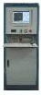

Controller screen:

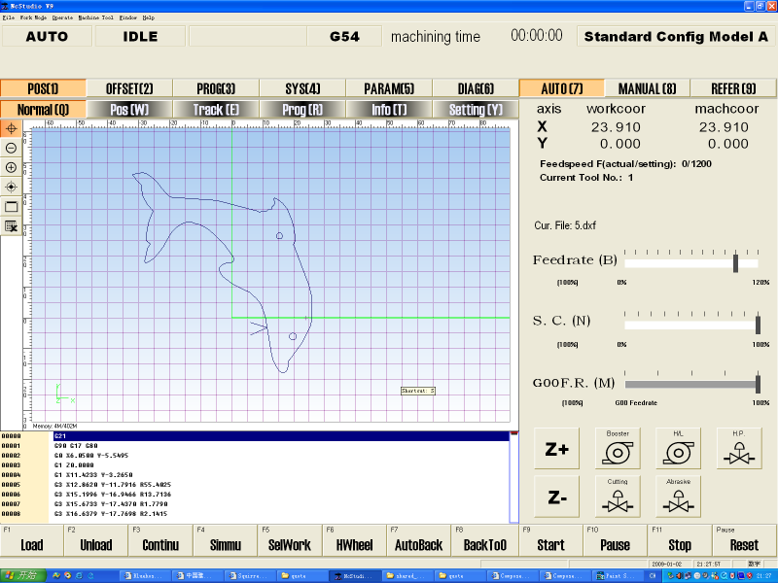

DXF file compatibility:

The controller is compatible to dxf file format. Users can save design drawing in .dxf from AutoCAD and read the file into the controller. Controller will post the dxf file to G-code. The controller can also read G-code generated from other CAM software. Controller software interface is based on Microsoft Windows 98/Me/XP/VISTA.

Advanced CAD/CAM software (optional): for design drawing, automatically generating machine path, lead in/out, nesting, tool offset, and generate G code. Features are similar to AutoCAD, and with rich features of CAM.

Automatic abrasive feeder (optional):

This equipment is highly recommended.

- Requires 70psi pneumatic source
- Capacity 40 Gallon.
- Self detecting empty/full status of reservoir and start/stop feeding.
- Model number ADS-04-170.

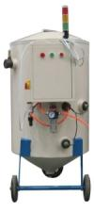

Operation cost and annual Maintenance cost
- Operation cost is about $25/hour
- Annual Maintenance cost is about $1000 per year.

Consumption of Sand: One ton of sand can be used for about 30 hours.

