Waterjet Cutting System Model Number: WC5WA4030H

Full abrasive waterjet cutting system consists of high pressure pump, cutting table with hopper, and CNC controller.

The high pressure pump:
Pump type: dual plunger reciprocal intensifier.
Intensifier driven by: hydraulic pump.
Max pressure: 55,000psi (380Mpa).
Max water flow rate: 0.8Gal/min (3.2L/min).
Attenuator 0.35Gal (1.4 Liters).
Cooling method: forced water. Or oil chiller as an option
Hydraulic fluid tank capacity: 42Gal (170L).
Water filter: 2 stage filtration included inside the pump unit.
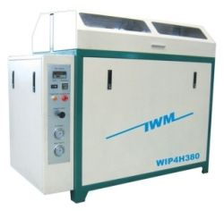

Power source: 3 phase, 380VAC, 50Hz (or 220V 60Hz), 37kw
Form size: 1600 x900 x1400mm, weight 1100kg.

Protective automatic shut off under the following circumstances:

- Over pressure limit.
- Over temperature limit.

Electrical circuitry enables soft start of the motor that lowers the instantaneous current requirement for electricity power supply.

CNC cutting table:

The table consists of water tank, X-Y motion system, Z axis motion, cutting head assembly, and abrasive reservoir with adjustable abrasive feed control. Overpass style. Cutting table working area size: 157"x118" (4000x3000mm). Water tank is made of stainless steel.
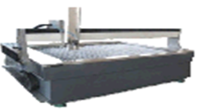

X-Y motion system consists of servo motor and driver, ball screw and precision linear guide. X-Y position accuracy is +/-0.002"(+/-0.05mm), repeatability is +/-0.0004"(+/-0.01mm). Over all cutting accuracy is at max of +/-0.006"(+/-0.15mm). This machine can cut all kinds of metal, marble, granite, glass, ceramic tile, rubber, plastic, virtually any materials. This machine can cut metal up to 100mm thick. Under water cutting is available with this model to reduce noise and splash.

Cutting head:

Pneumatically operated on/off valve, self-aligned cutting head. Maximum Abrasive flow rate: approximately 1lb/min (0.5kg/min). Compressed air source is necessary. An air compressor is optional item from manufacturer. As an option, the cutting head can manually tilt in both x and y directions +/- 15 degrees.

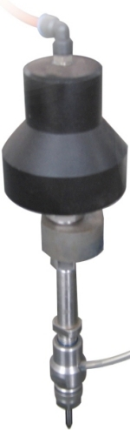

CNC controller:

Advanced industrial grade computer. The controller is capable of X-Y axis interpolation movement. Accelerate or decelerate the motion and high speed travel from point to point. Simulation without motion or dry run with axis motion but no jetting of water/abrasive are features included. Error stop and trace repeat are also very useful features. Out of range warning and hard stop to prevent damage of the cutting head. Emergency shut off switch is provided.

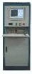

Software

The machine comes with advanced CAD/CAM software: for design drawing, generating machine path and lead in/out, nesting, tool offset, and generate G code.

Automatic abrasive feeder:

This equipment is highly recommended for large tables.
- Requires 70psi (0.8Mpa) compressed air source
- Capacity 40 Gallon of abrasive.
- Self detecting empty/full status of reservoir and start/stop feeding.
- Model number ADS-04-170.

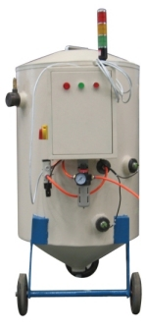

Accessories included in standard package:

High pressure tubing
Electrical cable
1 pcs nozzle, 1 pcs orifice, 1 tube of blue goop.
1 set of special tools for pump maintenance.

Spare parts kit (optional).

Including 10 nozzle, 20 orifice, 1 HP cylinder, 1 check valve body, 2 HP seal kits, 2 check valve repair kits, 2 on/off valve repair kits.

Condition and terms of sale:
The sale is final, no return for refund or exchange.

Payment Terms
Price: US$124,900 FOB Los Angeles, USA

- Tilting cutting head- beveling cutting up to 15 Degrees ..…..….……..US$500.00
- Electrical oil chiller…………………………………………..…....…..US$6500.00
- Abrasive removal system ……………………………………………..US$19900.00
- Extra spare parts package……………………………………..…....….US$3500.00
(includes: 10 nozzles, 20 orifices, 1 HP cylinder, 1 check valve body, 2 HP seal kits, 2 LP seal kits, 2 check valve repair kits, 2 on/off valve repair kits)

Terms of payment:
- 30% at time of ordering.
- 70% before shipping.
Payment terms can be negotiated, and must be approved by manufacturer.
Delivery Terms
- 12 weeks from receiving the 30% advanced payment.
- Full container load.
- FOB Los Angeles, California, USA
- Manufacturer is responsible for adequate packing for sea shipping.

After Sale Service
- Free on site installation.
- Free training included.

Warranty

Warranty period is two years, or 2000 operation hours whichever comes first limited warranty from the date customer receives the order. If a part fails due to defectiveness within the first half of the warranty period, seller will provide replacement part free of charge. Replacement part shipping cost is on buyer. If a part fails after half of the warranty period, seller will reimburse the value proportion to the remaining of the warranty period. Damage caused by user error is not covered by this warranty. Consumable parts such as nozzle, orifice, seals, and check valves, etc, are excluded from this warranty. Seller is not liable to any damage or lost from using the machine and not liable to any lost due to the down time of the machine for any reason.

Validity
- 90 days from the date of this proposal

Thank you for your interest, please kindly contact us if you need further details or if you have any questions.

