Waterjet Cutting System Model Number: WC5WA4824H

Full abrasive waterjet cutting system consists of high pressure pump, cutting table with hopper, and CNC controller.

The high pressure pump:
Pump type: dual plunger reciprocal intensifier.
Intensifier driven by: hydraulic pump.
Max pressure: 55,000psi (380Mpa).
Max water flow rate: 0.8Gal/min (3.2L/min).
Attenuator 0.35Gal (1.4 Liters).
Cooling method: forced water. Or oil chiller as an option
Hydraulic fluid tank capacity: 42Gal (170L).
Water filter: 2 stage filtration included inside the pump unit.
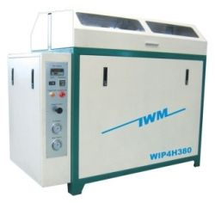

Power source: 3 phase, 380VAC, 50Hz (or 220V 60Hz), 37kw
Form size: 1600 x900 x1400mm, weight 1100kg.

Protective automatic shut off under the following circumstances:

- Over pressure limit.
- Over temperature limit.

Electrical circuitry enables soft start of the motor that lowers the instantaneous current requirement for electricity power supply.

CNC cutting table:

The table consists of water tank, X-Y motion system, Z axis motion, cutting head assembly, and abrasive reservoir with adjustable abrasive feed control. Overpass style. Cutting table working area size: 4800x2400mm. Water tank is made of stainless steel.
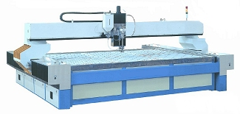

X-Y motion system consists of servo motor and driver, ball screw and precision linear guide. Z-axis motion is driven by AC motor with speed reducer. X-Y position accuracy is +/-0.06mm, repeatability is +/-0.03mm. Over all cutting accuracy is at max +/-0.15mm. This machine can cut all kinds of metal, marble, granite, glass, ceramic tile, rubber, plastic, virtually any materials. This machine can cut metal up to 100mm thick. Under water cutting is available with this model to reduce noise and splash.

Cutting head:

Pneumatically operated on/off valve, self-aligned cutting head. Maximum Abrasive flow rate: 0.5kg/min (1lb/min). Compressed air source is necessary. An air compressor is optional item from manufacturer. As an option, the cutting head can manually tilt in both x and y directions.

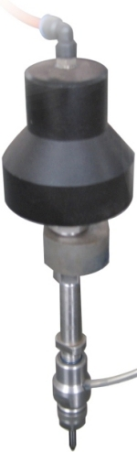

CNC controller:

Advanced industrial grade computer. The controller is capable of X-Y axis interpolation movement. Accelerate or decelerate the motion and high speed travel from point to point. Simulation without motion or dry run with axis motion but no jetting of water/abrasive are features included. Error stop and trace repeat are also very useful features. Out of range warning and hard stop to prevent damage of the cutting head. Emergency shut off switch is provided. Remote control is provided to move X-Y-Z axis when operator is away from the controller tower

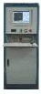

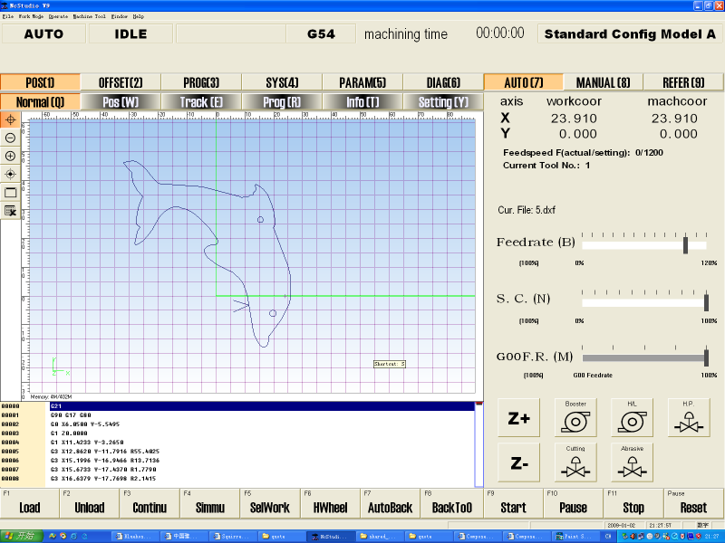

DXF file compatible:

The controller is compatible to dxf file format. Users can save design drawing in .dxf from AutoCAD and read the file into the controller. Controller will post the dxf file to G-code. The controller can also read G-code generated from other CAM software. Controller software interface is based on Microsoft Windows 98/XP/VISTA. Both metric and British unit versions are available.

Advanced CAD/CAM software (optional): for design drawing, define machine path and lead in/out, nesting, tool offset, and generate G code. Features are similar to AutoCAD, and with rich features of CAM.

Automatic abrasive feeder:

This equipment is highly recommended for large tables.
- Requires 70psi pneumatic source
- Capacity 40 Gallon.
- Self detecting empty/full status of reservoir and start/stop feeding.
- Model number ADS-04-170.

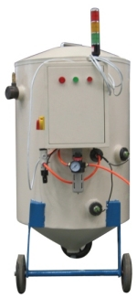

Accessories included in standard package:

High pressure tubing
Water hose
Electrical cable
1 pcs nozzle, 2 pcs orifice, 1 tube of blue goop.
1 set of special tools for pump maintenance.

Packing will fit 20 ft container.

There are three type of consumable:
- abrasive garnet. This we ship from China. $200/ton. Minimal order size ix 18 tons, each ton is good for 30 hours.
- nozzle: $95/each. Good for about 80 hours
- orifice: $15/each. Good for about 30 hours

