The model WC5WA6020H abrasive cutting system:

Cut all kinds of metal, marble, granite, glass, tile, plastic, rubber, and almost all materials.

Pump: model WIP5

High pressure pump type: reciprocal intensifier.
Maximum pressure: 400Mpa (60kpsi).
Maximum water flow rate 3.5L/minute (0.8Gal/min)
Pump cooling method: internal heat exchanger installed for water cooling. Oil chiller is optional.
Water Filter: 2-stage water filtration included.
Approximate size: 60" x 32" x 55" (1600x800x1400mm)
Power source: 3 phase, 380VAC, 50Hz, (or 220V 60Hz),
60 HP. Motor starting current requirement: >160Amp

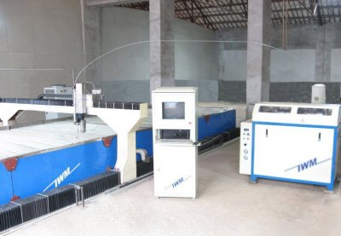

CNC Cutting table: model CAT6020H

The table consists of water tank, X-Y motion system, Z axis motion, cutting head assembly, and abrasive mini-hopper with adjustable abrasive feeding control.

Style: gantry.
Table structure: full stainless steel tank and cover.
Effective cutting area: 2000x6000mm.
Maximum Z-axis travel: 6" (150mm).
X-Y axis motion system: rack-pinion/ball screw, and linear motion guide.
X-Y axis motion drive: AC servo motor.
Z axis motion: AC motor with speed reducer. (servo motor optional)
Accuracy: 0.1mm/m.
Maximum X-Y axis travel speed 20m/min.
Out of range limiting sensor for both + and – directions on all axes.
Mechanical origin sensor for both X and Y axes.

Cutting head:

Cutting head has pneumatically operated on/off valve. Compressed air source is necessary. An air compressor is optional item from manufacturer. Capable of cutting up to 50mm mild steel and 25mm stainless steel. Optional feature: bevel cutting up to 45 degree with straight lines parallel to X or Y. Dual cutting head is also optional.
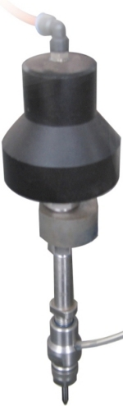

CNC controller:

CNC controller consists of advanced industrial grade computer, precision CNC hardware, and specialized software running on the Microsoft windows platform. The controller is capable of X-Y axis interpolation movement. Fast accelerate or decelerate motion and high speed travel from point to point. Simulation without motion or dry-run with axis movement but no jetting of water/abrasive are features included. Error stop and trace repeat are also very useful features. Out of range warning and hard stop to prevent damage capability are embedded in the system to prevent damage of machine. Emergency shut off switch is provided. CNC controller system is based on Microsoft Windows 98/XP/VISTA and is very easy to learn and operate. Both metric and imperial versions are available.

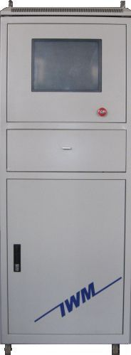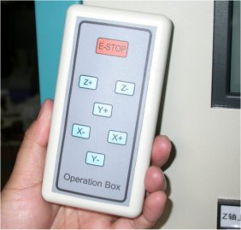

Controller Tower Remote Control

Controller Screen preview

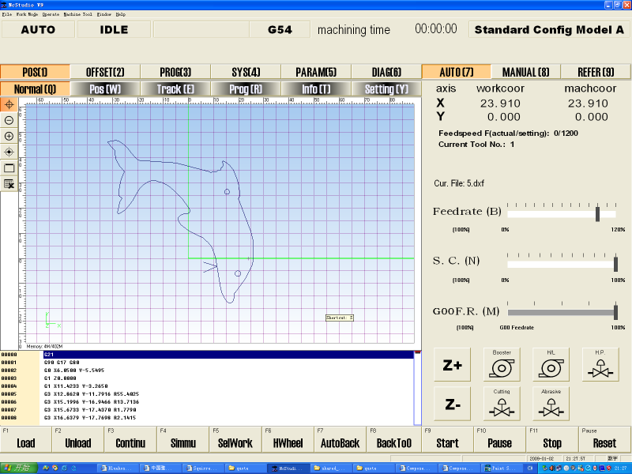

User Interface of Controller

Advanced CAD/CAM software (optional):

We offer optional CAD/CAM software for design drawing, automatically generating machine path, lead in/out, nesting, tool offset, and posting G code. This software has two parts, one is similar to AutoCAD (computer aid design), and the other is with rich features of CAM (computer aid machining). This software can also read dxf file generated from other software.

DXF file compatible:

The controller is compatible to dxf file format. Users can save design drawing in dxf format from AutoCAD or other software and read the file into the controller. Controller will post the dxf file to G-code. The controller can also read G-code generated from other CAM software. Controller software interface is based on Microsoft Windows 98/Me/XP/VISTA.

Automatic abrasive feeder(optional):

- Requires 70psi pneumatic source
- Capacity 40 Gallon.
- Self detecting empty/full status of reservoir and start/stop feeding.
- Model number ADS-04-170.

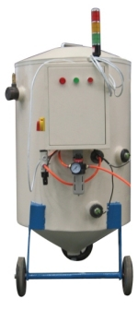

Accessories included in standard package:

High pressure tubing, Water hoses, Electrical cable, 1 pcs nozzle, 2 pcs orifice, 1 tube of Blue Goop.
1 set of special tools for pump maintenance.

