The model WC5WA8020H abrasive cutting system:

Pump:

High pressure pump type: reciprocal intensifier.
Maximum pressure: 380Mpa (55000psi).
Maximum water flow rate 3.5L/minute (0.8Gal/min)
Pump cooling method: water. Oil chiller is optional.
Water Filter: 2-stage water filtration included.
Approximate size: 60" x 32" x 55" (1600x800x1400mm)
Power source: 3 phase, 380VAC, 60Hz, (or 3ph 220V 60Hz) 37kw, 50 HP. Motor starting peak current requirement is 200Amp.

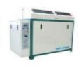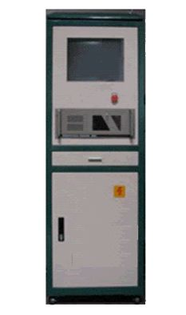
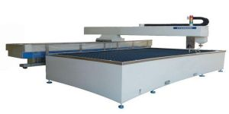

CNC Cutting table:

Style: cantilever.
Effective cutting area: 2000x8000mm.
Maximum Z-axis travel: 6" (150mm).
X-Y axis motion system: rack-pinion/ball screw, and
linear motion guide.
X-Y axis motion drive: AC servo motor.
Water tank made of stainless steel.
Z axis motion: AC motor with speed reducer. (servo motor optional)
Cutting tolerance: 0.3mm/m.
Repeat accuracy +/-0.1mm/m.
Maximum X-Y axis travel speed 8m/min.

Cutting head:

Cutting head has pneumatically operated on/off valve. Compressed air source is necessary. An air compressor is optional item from manufacturer. Capable of cutting up to 70mm mild steel and 40mm stainless steel. Optional feature: bevel cutting up to 45 degree with straight lines parallel to X or Y.
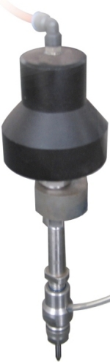

CNC controller:

CNC controller is of advanced industrial grade computer. The controller is capable of X-Y axis interpolation movement. Accelerate or decelerate the motion and high speed travel from point to point. Simulation without motion or dry-run with axis movement but no jetting of water/abrasive are features included. Error stop and trace repeat are also very useful features. Other features include out of range warning and hard stop to prevent damage of the cutting head. Emergency shut off switch is provided. CNC system is based on Windows operating system winXp/Vista and is very easy to learn and operate. Controller software interface runs on Microsoft Windows 98/XP/VISTA. Both metric and imperial versions are available.

DXF file compatible:

The controller is compatible to dxf file format. Users can save design drawing as .dxf from AutoCAD and read the file into the controller. Controller will post the dxf file to G-code. The controller can also read G-code generated from other CAM software.

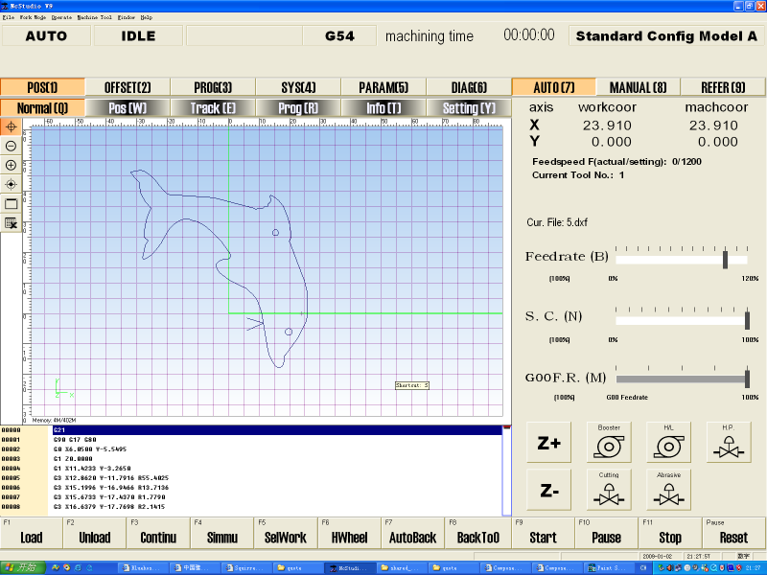

User Interface of CNC Controller

Advanced CAD/CAM software (optional):

We offer optional CAD/CAM software for design drawing, automatically generating machine path, lead in/out, nesting, tool offset, and posting G code. This software has two parts, one is similar to AutoCAD (computer aid design), and the other is with rich features of CAM (computer aid machining). This software can also read dxf file generated from other software.

Automatic abrasive feeder:

- Requires 70psi pneumatic source
- Capacity 40 Gallon.
- Self detecting empty/full status of reservoir and start/stop feeding.
- Model number ADS-04-170.

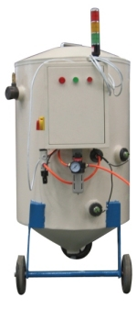

Accessories included in standard package:

High pressure tubing, Water hoses, Electrical cable, 1 pcs nozzle, 2 pcs orifice, 1 tube of Blue Goop.
1 set of special tools for pump maintenance.

Spare parts kit (optional).

Including 10 nozzles, 20 orifices, 1 HP seal kit, 1 LP seal kit, 1 HP cylinder, 1 check valve body, 1 check valve repair kit, 1 on/off valve repair kit.

